Chapter 11, Problem 54.

For the network in Fig. 11.73, find the complex power absorbed by each element.

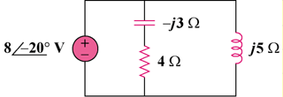

Figure 11.73
For Prob. 11.54.

